CODIFIED ORDINANCES OF URBANCREST

PART NINE - STREETS, UTILITIES AND PUBLIC SERVICES CODE

TITLE ONE - Street and Sidewalk Areas
Chap. 901. Excavations.
Chap. 905. Driveways and Curb Cuts.

TITLE THREE - Utilities
Chap. 925. Sewers.
Chap. 929. Water.

TITLE FIVE - Other Public Services
Chap. 945. Garbage and Refuse Collection.
Chap. 949. Weeds and Litter.
Chap. 953. Property Maintenance Assistance Program.

TITLE ONE - Street and Sidewalk Areas

Chap. 901. Excavations.
Chap. 905. Driveways and Curb Cuts.

CHAPTER 901
Excavations

901.01 Bond required.
901.02 Pavement and utility cut repair standards.

CROSS REFERENCES
Assessments - see Ohio R.C. 701.05 , Ch. 727
Openings by municipality - see Ohio R.C. 723.02
Surface treatment - see Ohio R.C. 723.23, 723.31
Excavation liability - see Ohio R.C. 723.49 et seq.
Digging, excavating and piling earth on streets - see Ohio R.C. 5589.10
Fees - see BLDG. 1313.01

901.01 BOND REQUIRED,
(a) No person, or group, or company shall cut into, break, or in any way disturb or move the pavement, concrete, curb, drains, sewer lines, or any part thereof without first posting bond in the amount of two thousand dollars ($2,000) to insure the proper repair thereof. The bond shall be cash or performance bond.

(b) The sewer tapper shall post bond of two thousand dollars ($2,000) with the Village Fiscal Officer for each opening of a street to insure proper repair and replacement.

(c) The Clerk of the Board of Trustees of Public Affairs shall require a written statement from the Fiscal Officer certifying that proper bond has been posted before issuing any permit for sewer, or water taps, and shall file this certification with the permits.

(d) Where one sewer line and/ or water line is being installed to the same lot or parcel, only one bond shall be required for both installations.

(e) A two thousand dollar (332,000) bond shall be required on all installations where the street has to be cut or undermined without regard to minimum dimensions of the cut.

(f) Any person violating this section shall be guilty of a misdemeanor of the third degree. (Ord. 8l-02. Passed 3-3-81.)

901.02 PAVEMENT AND UTILITY CUT REPAIR STANDARDS.
The pavement and utility cut repair standards, attached hereto and incorporated herein are hereby adopted by the Village. (Ord. 96-12. Passed 11-5-96.)

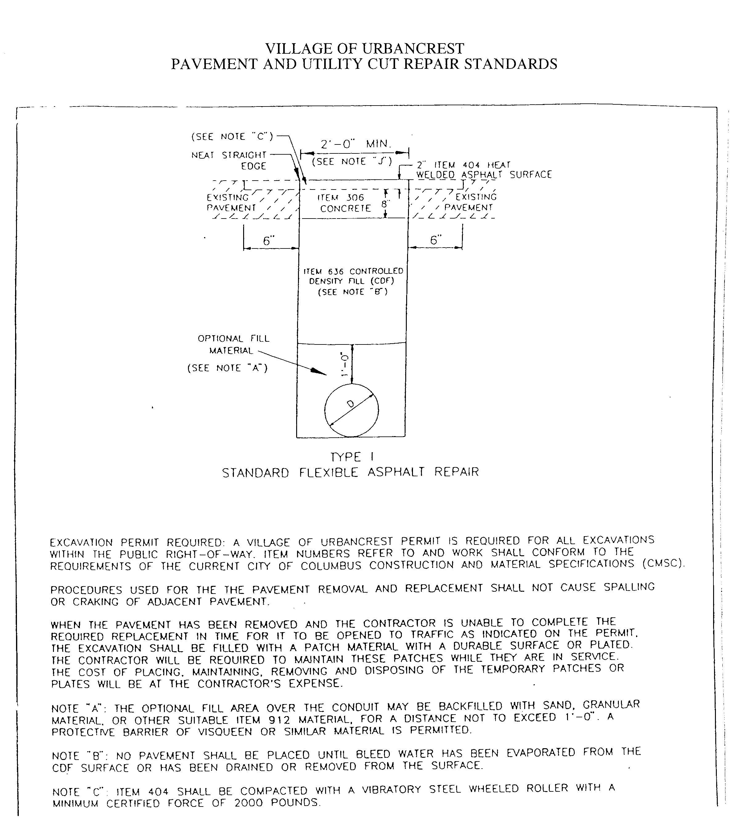

CHAPTER 905
Driveways and Curb Cuts

905.01 Specifications adopted.

CROSS REFERENCES
Fees - see BLDG. 1313.01

905.01 SPECIFICATIONS ADOPTED.
(a) A driveway approach shall be provided for all new residential driveway units built in the Village.

(b) The minimum driveway width shall be ten feet; the maximum approach width at the curb shall be twenty-four feet for new and existing residential dwelling units.

(c) When a new curb cut is required on a street having combination curb and gutter six inches high, the entire section of the curb shall be removed and replaced with dropped curb conforming to standard construction drawing number 1152 DR A City of Columbus, Ohio, attached hereto and made a part of the section as modified for the Village.

(d) The approach within six feet from the back of the curb shall be concrete six inches deep utilizing a six bag mix per cubic yard (CIF Section 499).

(e) The permit fee for the concrete-approach construction in the right of way shall be as provided in Section 1313.01.

(f) The person or firm doing construction hereunder shall be required to post a performance bond of fifteen hundred dollars ($l ,500) prior to removal or cutting of the curb.

(g) There shall be an inspection and approval by the Village prior to curb replacement and driveway approach construction in the right of way.

(h) It is required that a feathered curb return be provided when installing an approach on a six inch deep street curb (see detail). (Ord. 81-15. Passed 7-7-81.)
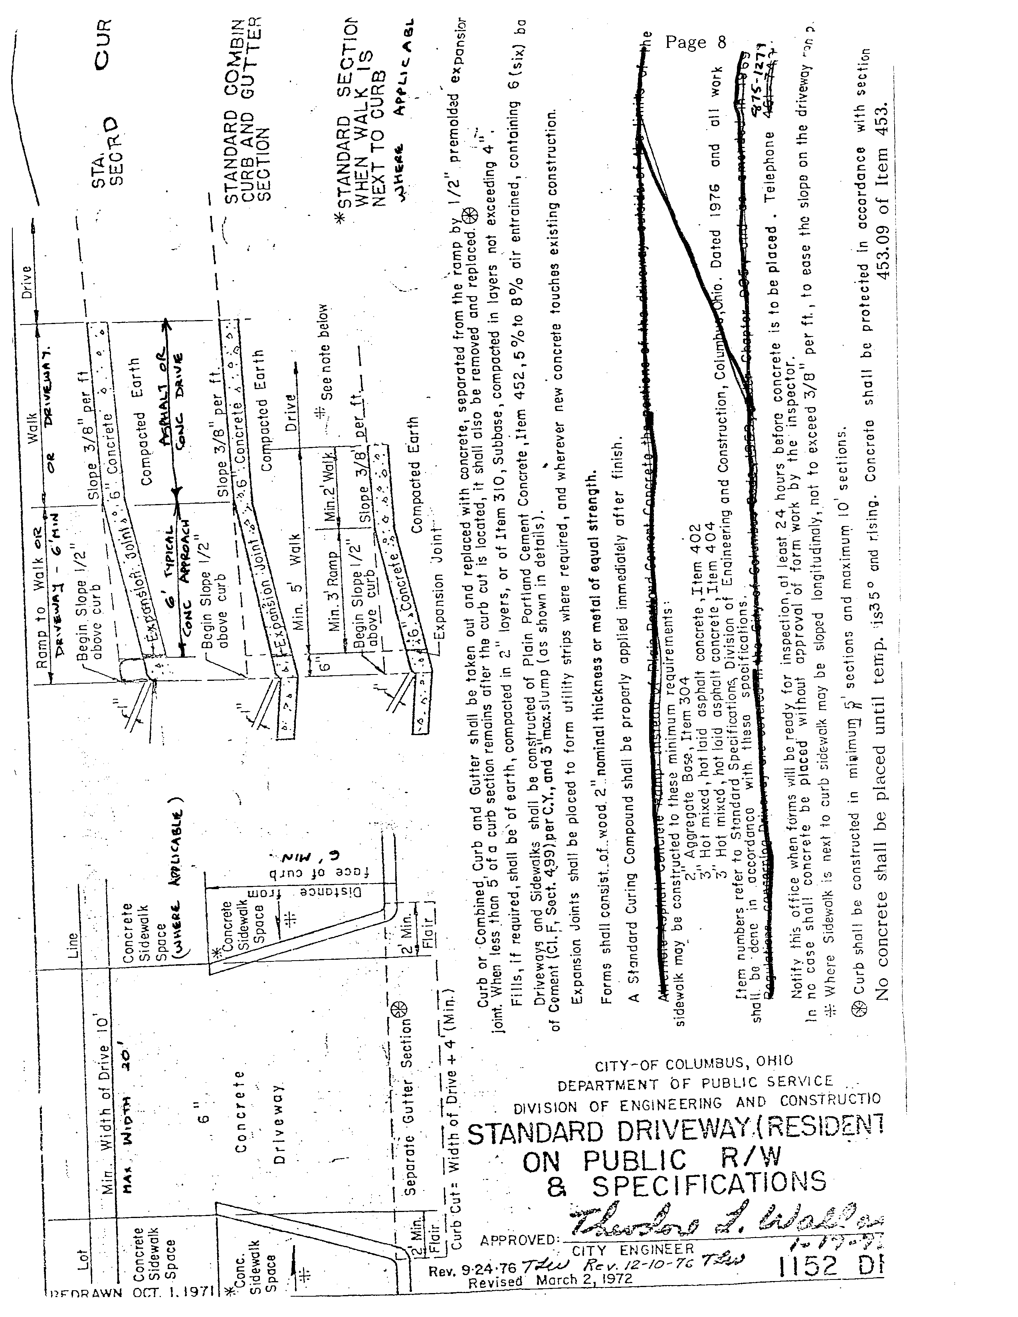

TITLE THREE - Utilities

Chap. 925. Sewers.
Chap. 929. Water.

CHAPTER 925
Sewers

925.01 Sewer tap permit fee.
925.02 Prohibiting clean water connections to the sanitary sewer system.
925.03 Private sewer disposal systems.

CROSS REFERENCES
Compulsory sewer connections - see Ohio R.C. 729.06
Management and control of sewer system - see Ohio R.C. 729.50
Untreated sewage - see Ohio R.C. 3701.59
Interference with sewage flow - see Ohio R.C. 4933.24

925.01 SEWER TAP PERMIT FEE.
The following fees are the newly established sewer tap permit fees as recommended by the Board of Trustees of Public Affairs.

Tap Size  (Inches) | City of Columbus Sewer Fee |  | Urbancrest Surcharge % | Urbancrest Surcharge Fee | Inspection Fee | Total Fee
3/4 domestic water | $3044.00 |  | 70% | $2130.80 | $85.00 | $5259.80
1 | $5,074.00 |  | 100% | $5,074.00 | $85.00 | $10,233.00
1-1/2 | $10,147.00 |  | 100% | $10,147.00 | $85.00 | $20,379.00
2 | $16,235.00 |  | 100% | $16,235.00 | $85.00 | $32,557.00
3 | $32,472.00 |  | 100% | $32,472.00 | $85.00 | $65,029.00
4 | $50,737.00 |  | 100% | $50,737.00 | $85.00 | $101,559.00
6 | $101.475.00 |  | 100% | $101.475.00 | $85.00 | $203,035.00
8 | $162,360.00 |  | 100% | $162,360.00 | $85.00 | $324,805.00
10 | $233.392.00 |  | 100% | $233.392.00 | $85.00 | $466,869.00
12 | $463,342.00 |  | 100% | $463,342.00 | $85.00 | $872,769.00
16 | $484,194.00 |  | 100% | $484,194.00 | $85.00 | $968,473.00

(b) The Village shall be responsible for collecting the full payment (City of Columbus sewer fee and the Village of Urbancrest surcharge fee) and remitting the City of Columbus sewer fee to the City of Columbus pursuant to the existing agreement with the City of Columbus.

(c) The established fees are based upon the City of Columbus fees. Village fees are subject to change and shall be effective on the date in which the City of Columbus has a fee increase.

(d) Council for the Village authorizes a revised Sewer Tap Permit Form attached as Exhibit A to Ordinance 07-02. (Ord. 07-02. Passed 3-6-07.)

925.02 PROHIBITING CLEAN WATER CONNECTIONS TO THE SANITARY SEWER SYSTEM.
(a) Roof drains, foundation drains or other clean water connections to the sanitary sewer system in the Village are prohibited.

(b) No person shall connect storm water or roof water leaders with the sanitary system of sewers in the Village, or let into or connect with any soil pipe, house drain or house sewer tributary to the sanitary system of sewers. (Ord. 93-05. Passed 10-5-93.)

(c) Whoever violates this section is guilty of a misdemeanor of the third degree.

925.03 PRIVATE SEWER DISPOSAL SYSTEMS.
(a) No owner, agent, lessee, tenant or occupant of any lot or land located within this Village shall establish, construct, use, maintain or permit to remain a privy, cesspool or other receptacle for sewage or excreta, or a connection to a private sewer, ditch or other outlet, if such lot or land is accessible to a public sewer constructed and used for the purpose of conveying sewage and if a connection to such public sewer is not made within the time hereinafter prescribed. When such public sewer is available or is hereafter made available, a connection to such public sewer shall, within one year after the date of such accessibility, be established and used by such owner, agent, lessee, tenant or occupant. (Ord. 70-89. Passed 10-6-70.)

(b) Any owner, agent, lessee, tenant or occupant who violates this section is guilty of a misdemeanor of the fourth degree, for each offense. A separate offense shall be deemed to have been committed each period of twenty-four hours during which such violation shall continue after a period of thirty days following the original conviction. (Ord. 01-05. Passed 5-23-01.)

CHAPTER 929
Water

929.01 Village fee for water taps.

CROSS REFERENCES
Power to provide and regulate Water system - see Ohio R.C. 715.08, 717.0l, 743.01
Water pollution - see Ohio R.C. 715 .O8, 743.25
Compulsory water connections - see Ohio R.C. 729.06, 743.23
Management and control of Water Works - see Ohio R.C. 735.28 et seq.

929.01 VILLAGE FEE FOR WATER TAPS.
The Village fee for Water taps shall be four hundred and eighty dollars ($480.00)

TITLE FIVE - Other Public Services

Chap. 945. Garbage and Refuse Collection.
Chap. 949. Weeds and Litter.
Chap. 953. Property Maintenance Assistance Program.

CHAPTER 945
Garbage and Refuse Collection

945.01 Collection required.
945.02 List maintained.
945.03 License required; fee.
945.04 Requirements for licensees.
945.99 Penalty.

CROSS REFERENCES
Collection and disposal of garbage - see Ohio R.C. 7l5.43, 717.01
Vehicle loads dropping, sifting, leaking - see TRAF. 339.08
Littering and deposit of garbage, rubbish, and junk - see GEN. OFF. 521.07

945.01 COLLECTION REQUIRED.
Owners of residential households and/or their tenants are hereby required to arrange for weekly garbage and refuse collection with any person, firm or corporation licensed by the Village for collection of garbage and refuse. (Ord. 88-08. Passed 7-5-88.)

945.02 LIST MAINTAINED.
The Village Fiscal Officer shall maintain a current list of all licensed garbage and refuse collectors authorized to do business in the Village, including the name, address, telephone number and rates for weekly garbage and refuse collection. Information from this list shall be posted in the Administration Building and made available to the public. (Ord. 88-08. Passed 7-5-88.)

945.03 LICENSE REQUIRED; FEE.
(a) Any person, firm or corporation desiring to collect, transport and remove garbage and trash of residential householders shall be required annually to make application for a license for garbage and refuse collection on forms provided for by the Village.
(b) The annual license fee for garbage and refuse collection shall be $100.00
(Ord. 88-07. Passed 7-5-88.)

945.04 REQUIREMENTS FOR LICENSEES.
(a) All applicants for a license shall certify their full compliance with all Village ordinances and regulations, including but not limited to regulations governing the payment and collection of income taxes, compliance with health codes and equal employment opportunities.

(b) All applicants for a license shall make at least one regular weekly collection of garbage and refuse from residential householders with Whom they contract. Provided however, a licensee shall not be required to collect garbage that is not properly Wrapped or containerized.

(c) All applicants for a license shall make or have arrangements for the garbage and refuse to be disposed of at a site outside the Village limits.

(d) All applicants for a license shall provide evidence of insurance, insuring persons and property from injury and damage in amounts not less than $100,000 per occurrence.
(Ord. 88-07. Passed 7-5-88.)

945.99 PENALTY.
Any person or entity that violates Section 945.03 and 945.04 is guilty of a misdemeanor of the fourth degree. A separate offense shall be deemed to have been committed each time the person or entity collects garbage, refuse and/or debris without complying with Sections 945.03 and 945 .04.

CHAPTER 949
Weeds and Litter

949.01 Prohibited.
949.02 Notice.
949.03 Failure to comply.
949.99 Penalty.

CROSS REFERENCES
List of prohibited and secondary noxious weeds - see OAC 901:5-27-06; 901:5-37-01

949.01 PROHIBITED.
(a) All noxious weeds growing or otherwise existing upon any land within the Village are hereby declared a public nuisance.

(b) Noxious weeds means and includes, but is not limited to, those grasses, weeds, brush, vines, shrubs, thistles, burdocks, jimson weeds, ragweeds, milkweeds, poison ivies, poison oaks, and any other plant species which may create a health hazard or endanger public safety, which exceed twelve inches in height, and for which no reasonable horticultural or agricultural use exists.

(c) It is the sole and absolute responsibility of each owner or person otherwise having charge of land in the Village to remove all noxious weeds from such land and to maintain such land free from any and all noxious weeds. (Ord. O5-04. Passed 4-5-05.)

949.02 NOTICE.
The Village of Urbancrest adopted the procedures outlined in Ohio R.C. 73l.5l, 731.52 and 73l.54, to notify property owners, lessees, agents, tenants or persons otherwise having charge of land in the Village to destroy and remove noxious weeds and litter from the Village.
(Ord. O5-04. Passed 4-5-05 .)

949.03 FAILURE TO COMPLY.
If the owner, lessee, agent, tenants, or persons otherwise having charge of land fail to comply with the notice to destroy and remove noxious weeds and litter, the Village is hereby authorized to cause such noxious weeds to be cut and destroyed or such litter removed, to employ the necessary help to perform the task and, make written return to the County Auditor of the amount paid to be entered upon the tax duplicate as a lien against the property pursuant to the provisions of Ohio R.C. 731.53 and 73l.54. (Ord. 05-04. Passed 4-5-05.)

949.99 PENALTY.
Whoever violates any provision of this chapter is guilty of a minor misdemeanor. Each day that any noxious weed is permitted to continue to grow and/or litter is permitted to continue to exist upon property within the Village after notification to remove same is given shall constitute a separate offense. (Ord. 05-04. Passed 4-5-05.)

CHAPTER 953
Property Maintenance Assistance Program

953.01 Program established.

953.01 PROGRAM ESTABLISHED.
(a) A Property Maintenance Assistance Program for Village residents sixty-two years of age or older is hereby established.

(b) The Village shall remove yard waste consisting of tree limbs, bushes, grass clippings and leaves only. Any forms of garbage, refuse and bulk items are not eligible for pickup through the Property Maintenance Assistance Program.

(c) The following procedures shall be followed for acquiring services provided by the Village Property Maintenance Assistance Program.
(1) Residents shall make a request for services by contacting the Village via telephone.
(2) The Street Commissioner or his designee shall make a visual assessment and approve the project.
(3) The resident shall remit payment to the Village Administration Building.
(4) Upon receipt of payment the Street Commissioner shall contact the resident and schedule a time to complete the project.

(d) The fee for the Village Property Maintenance Assistance Program shall be the following:
(1) $8.00 for a single load.
(2) Additional $3.00 will be added for each additional load.
(Ord. 07-09. Passed 8-7-07.)

